**Project Design Phase-II**

**Technology Stack (Architecture & Stack)**

|  |  |
| --- | --- |
| Date | 07 October 2022 |
| Team ID | PNT2022TMID54092 |
| Project Name | Gas leakage monitoring and alerting system for industries |
| Maximum Marks | 4 Marks |

**Technical Architecture:**

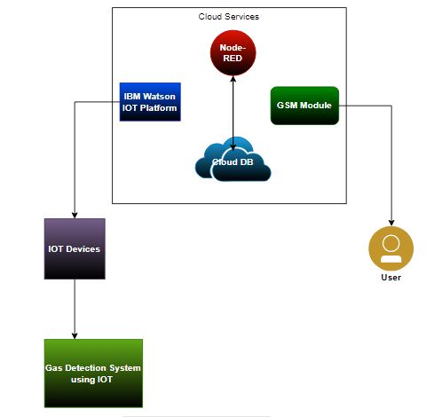

**Table-1 : Components & Technologies:**

|  |  |  |  |
| --- | --- | --- | --- |
| **S.No** | **Component** | **Description** | **Technology** |
| 1. | User Interface | The user needs to register and can see the other device. For example, through the web UI, mobile app,etc. | HTML, CSS, JavaScript |
| 2. | Application Logic-1 | The owner’s device must be connected to the system. | Python |
| 3. | Application Logic-2 | The owner’s device must be functional. | IBM Watson STT service |
| 4. | Application Logic-3 | When a gas leak is detected, a notification is sent to the owner. | IBM Watson Assistant |
| 5. | Database | The data type can be of any form like text, custom block of dataset to the cloud from the central IOT device,etc. | MySQL, etc. |
| 6. | File Storage | The file should be labelled, what it contains and how long it should be kept. | IBM Block Storage or Local Filesystem |
| 7. | External API-1 | The purpose of the external API used in the device is to use the internet to efficiently communicate ad perform assigned operations. | Aadhar API, etc. |
| 8. | Machine Learning Model | IOT & Machine learning bring insights otherwise hidden in data for fast automated response and better decision making. | Object Recognition Model, Danger Prediction Model, etc. |

**Table-2: Application Characteristics:**

| **S.No** | **Characteristics** | **Description** | **Technology** |
| --- | --- | --- | --- |
|  | Open-Source Frameworks | A device that eliminates much of the manual work of writing and configuring code. It offers fast development, is easy to configure and has a strong support base. | IOT Zeta for non-stop streaming of gas leakage level. |
|  | Security Implementations | Alarm notification activated with the GPS module received in the owner's mobile phone. | e.g. SHA-256, Encryptions, Firewalls, Antivirus, etc. |
|  | Scalable Architecture | If a haul arises owner will see the issues and check gas level at the same time . | Micro-services automated bootstrapping, data storage technologies. |
|  | Availability | Sensor to detect the leak and LCD screen to display the gas level. A message is sent to the owner each time a gas leak is detected. | Arduino, GSM Module. |
|  | Performance | An alarm notification is sent to the owner immediately when a leak is detected. Action is taken immediately upon detection. | High durable device battery. |